**Campaign unlock window**

We hope we could modify following text:

1: title.

2: context

3: reward (already done)

4: purchase button

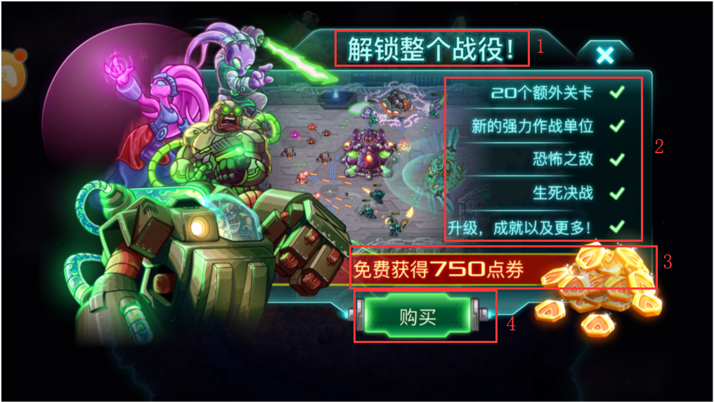

**Gift Bag**

Our colleagues and channels saw there have Gift bag in IOS version, it is possible to add gift bag for us? So, we can modify pack by ourselves.

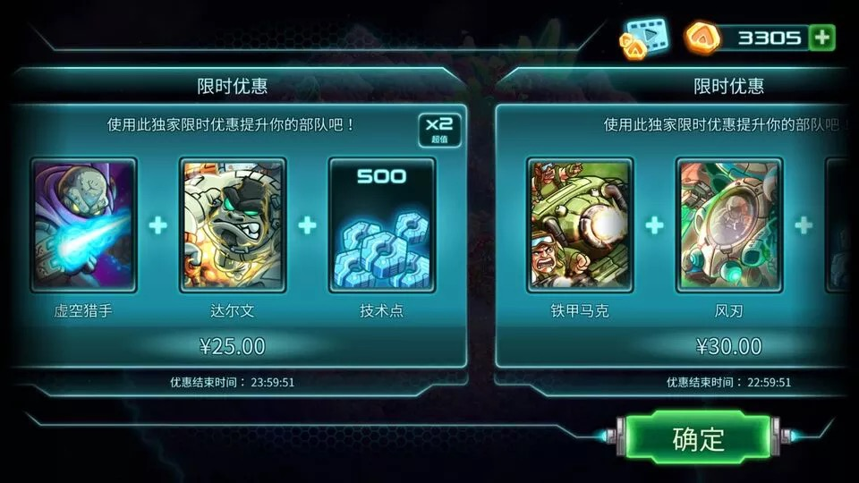

**AD**

Control showing AD button and call e2w ad method.

**Free Mode**

Some channels want to pay to play version, this version just hide store interface, if user move to store because of insufficient icon, also stop them go in. heroes will be given after each levels until all heroes are given.

**Cloud save**

Use e2w cloud save methods to game.